Assignment #1

Computer science

17011069 김성욱

Q#1 Create a simple C# Windows Forms application (WinForms App) in Visual Studio as shown in Lecture 2-1. Copy the code from the *.cs file and submit.

Code – Form1.cs

using System;

using System.Collections.Generic;

using System.ComponentModel;

using System.Data;

using System.Drawing;

using System.Linq;

using System.Text;

using System.Threading.Tasks;

using System.Windows.Forms;

namespace assignment

{

public partial class Form1 : Form

{

public Form1()

{

InitializeComponent();

}

private void Form1_Load(object sender, EventArgs e)

{

message.Text = "Welcome Message!";

}

private void okBTN_Click(object sender, EventArgs e)

{

message.Text = "You Clicked on OK!";

}

private void exitBTN_Click(object sender, EventArgs e)

{

Application.Exit();

}

}

}

Code – Program.cs

using System;

using System.Collections.Generic;

using System.Linq;

using System.Threading.Tasks;

using System.Windows.Forms;

namespace assignment

{

static class Program

{

/// <summary>

/// 해당 애플리케이션의 주 진입점입니다.

/// </summary>

[STAThread]

static void Main()

{

Application.EnableVisualStyles();

Application.SetCompatibleTextRenderingDefault(false);

Application.Run(new Form1());

}

}

}

Images

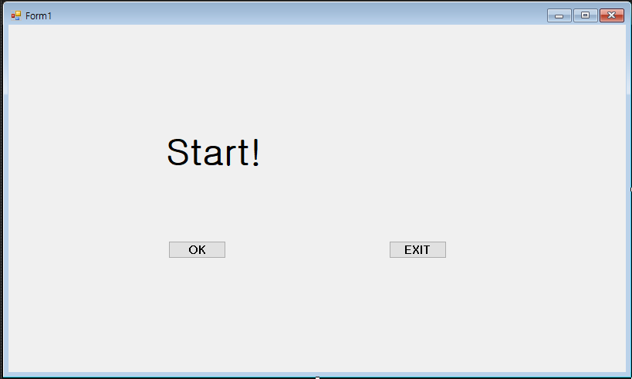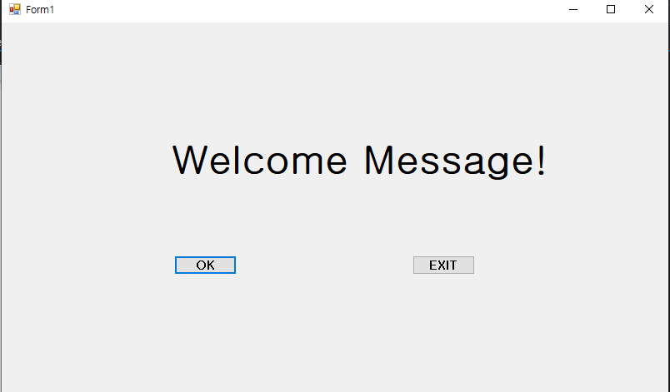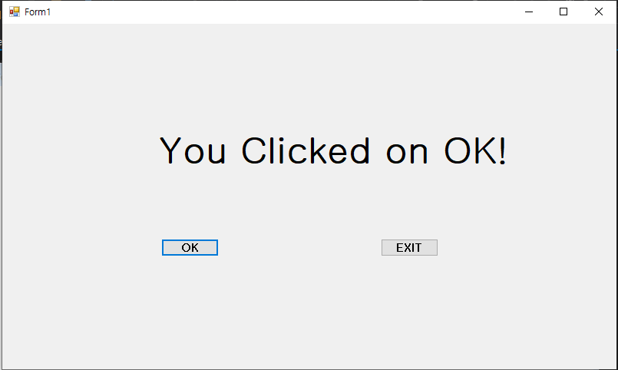

Q#2. Enter the following program in your editor and compile it.

1. Find which lines generate an error message.

static void Main(string[] args)

{

System.Console.WriteLine(Keep Checking Carefully~!); //this.code makes an error

System.Console.WriteLine(You will find the error soon!);// this.code makes an error

}

1. Correct the program and submit.

